Group A
- A do while loop is executed:

Answer:
At least once

- . What can be done using one type of loop can also be done using the other two types of loops, True or False?

Answer:
True, The work done by one type of work can also be done by another type

- Write an equivalent while() loop for the following for() loop.

int s=0;
for(int x=1; x<=25; x+=2)
s+=x;

Answer:
int s = 0,x = 1;
while(x<=25){
s+=x;
x+=2;
}

Group B
- Write a program to print numbers from 1 to 10.
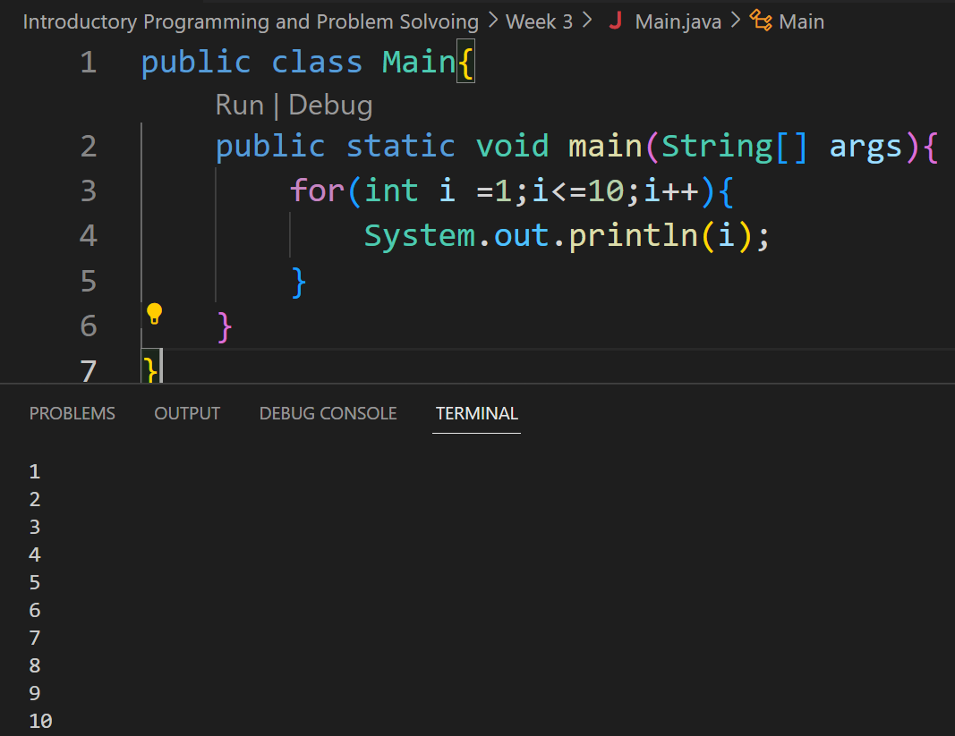

- Sum of first 10 numbers
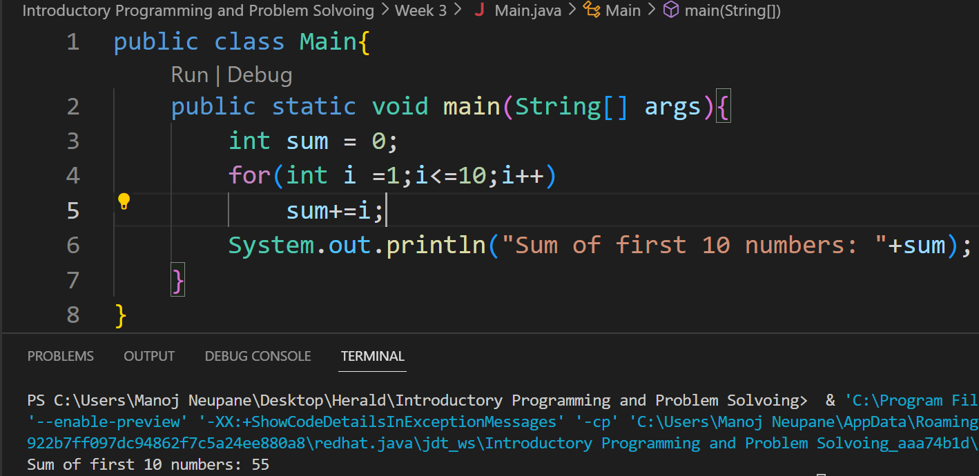
- Multiplication table of number from user.
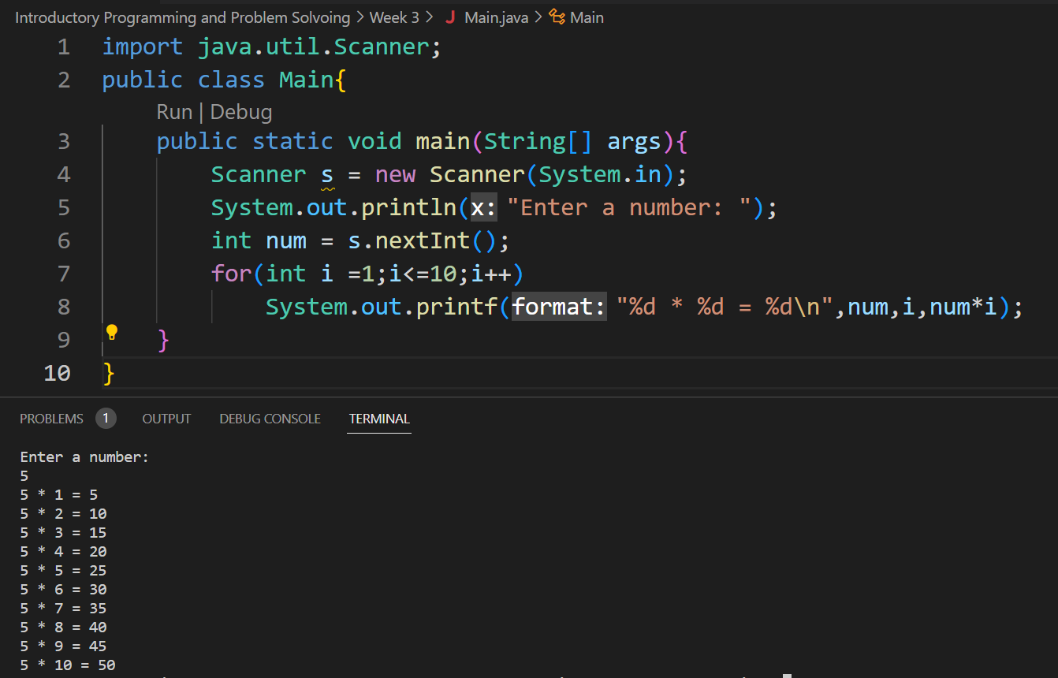

- Factorial of a given number
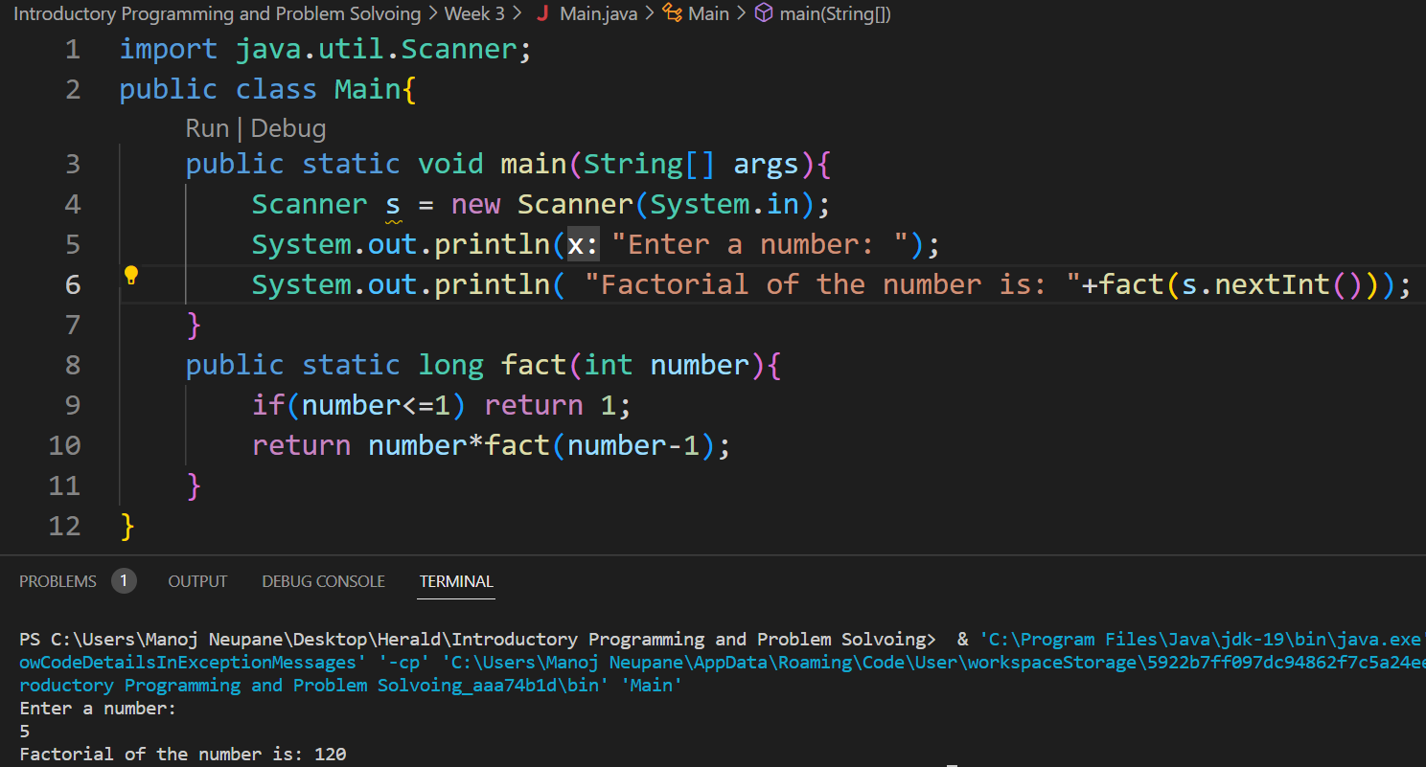
- A to the power of B (A,B are use inputs).
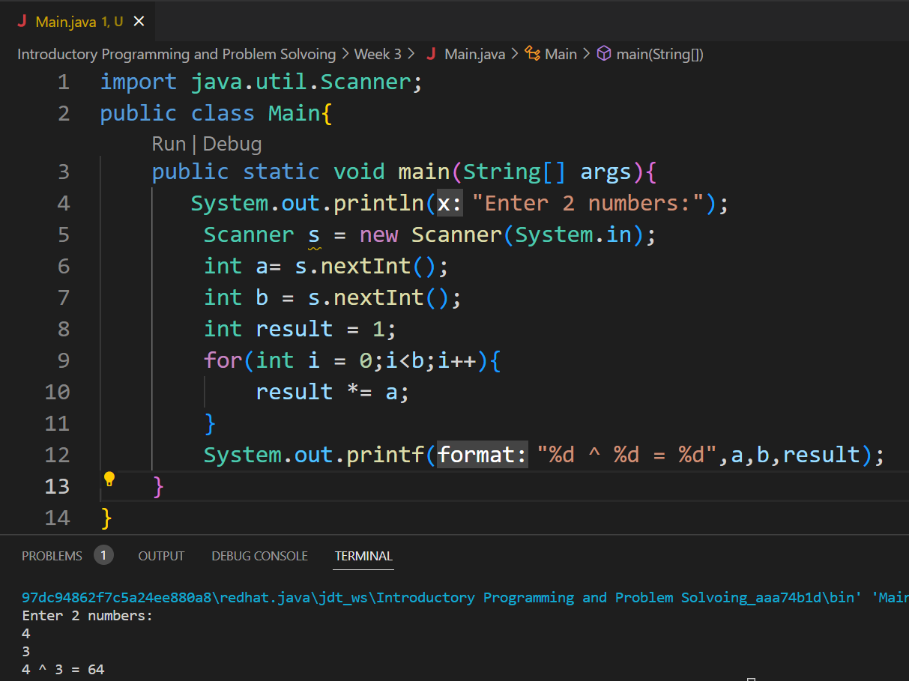
- Count how many positive, negative or zeros are entered by user.
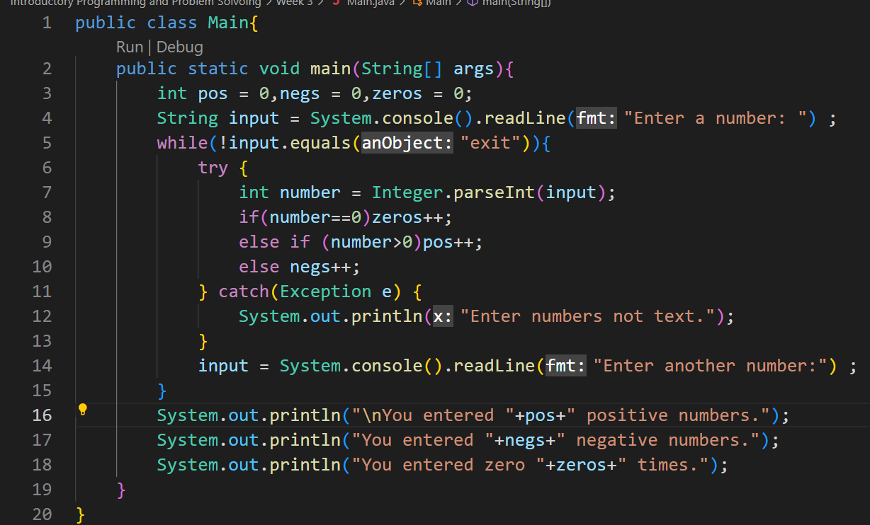
Output:
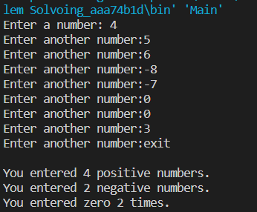

- Fibonacci Series
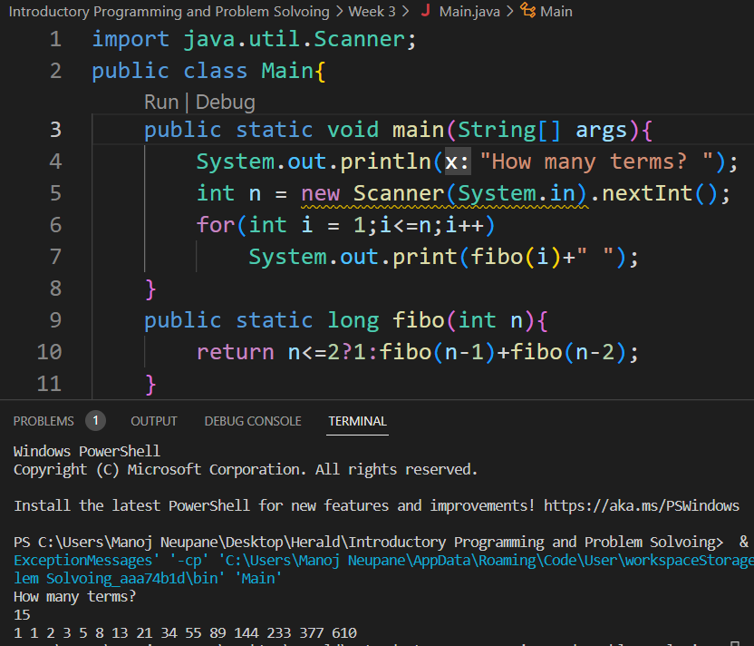

- Pattern pyramid of stars.
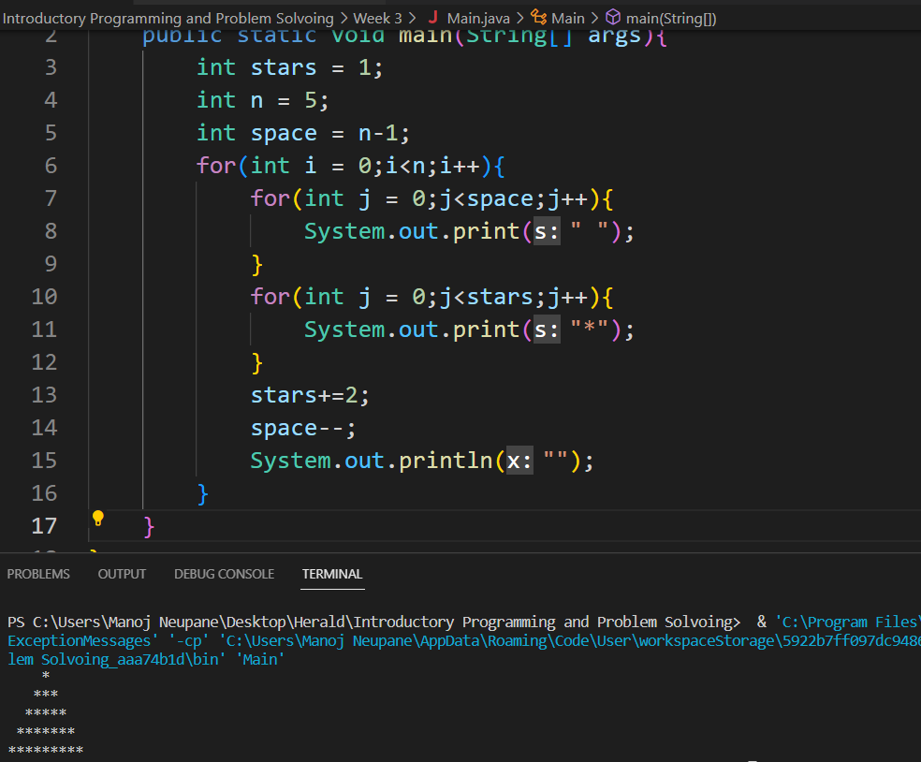

- Patterns pyramids of 1,22,333…
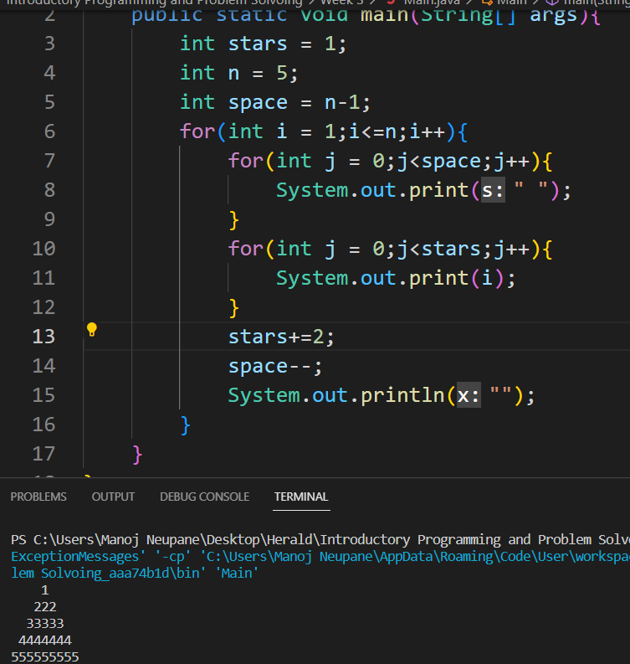

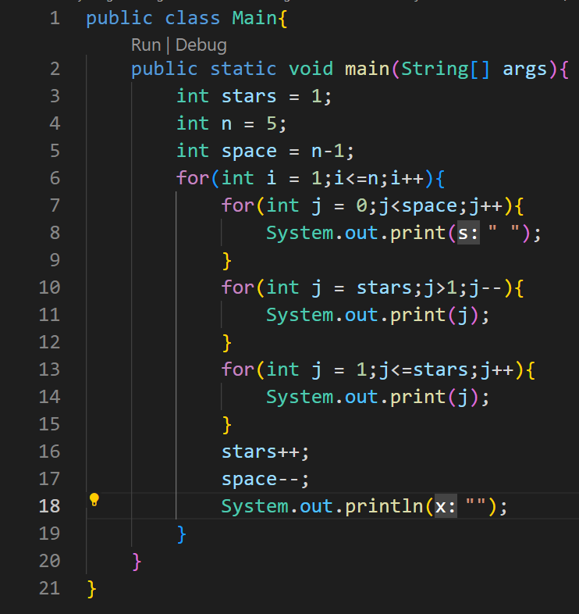
Output:
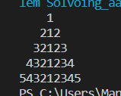

Group C

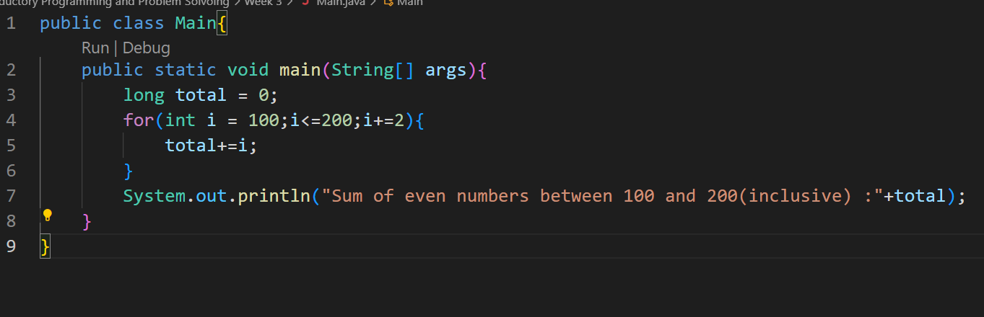
Output:
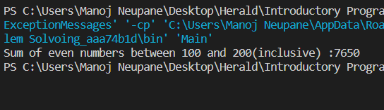

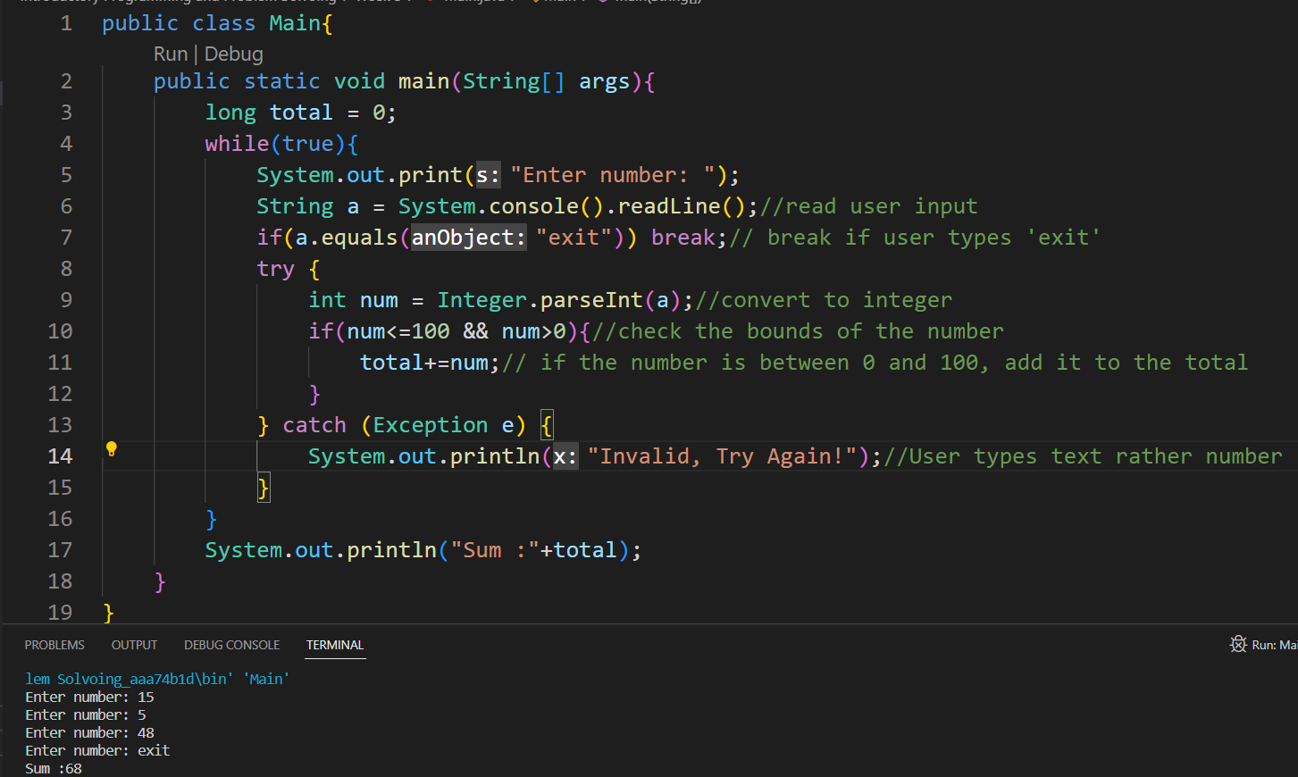

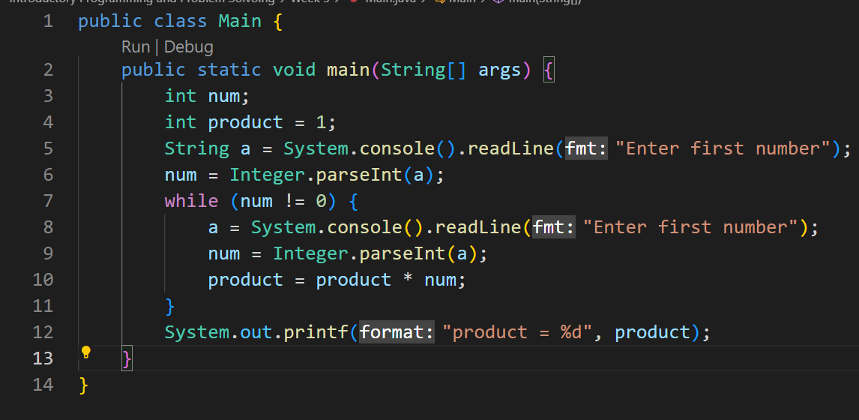

The given program has a logical error. Because of the line 10, when the user enters 0 at last to quit, the program multiplies the final product with that zero and results the product to 0 which is the bug of the program.
To fix this, line no. 10 should be moved above line no. 8 like following:
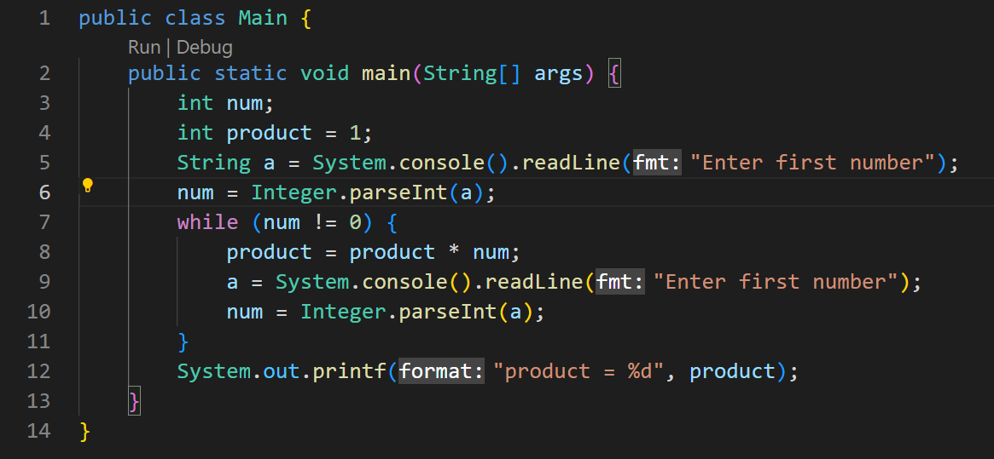

Output Before: Output After:

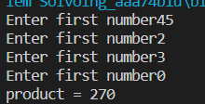
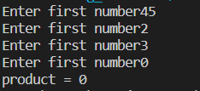

Answer: The program (a) represents indefinite loop because the number of times the instructions inside the loop is not predefined. It will vary according to the user input.

And, the program(b) is definite loop as it will run exactly 10 times.

Group D

